PENETRATION TESTING REPORT
FOOTPRINTING, RECONNAISSANCE & NETWORK SCANNING PHASES
W2-PM1 | CYBERSECURITY | NETWORKWALKS

Pentester Name  (Cybersecurity Professional) | Jovanie Spencer
Program/Batch | B083A-Networkwalks
Date | 17 September 2026
Module completed | W2-PM1 (Multiple Kali Tools)  W2-PM5 (Zenmap Scanning)
Client/Target | 1. Networkwalks (secured written permission already)  2. My own local LAN Network
Permission secured from client? | Yes
Phase covered | Phase 1: Reconnaissance & Footprinting; Phase 2: Scanning & Network Discovery

1. Liability Disclaimer
I have performed these activities only on the systems & devices where I had secured written permission or the devices/systems that I own myself. All these materials are for education and research purpose only. Do not use anything from here to break the law. The instructor, the authors and Networkwalks are not responsible for what you do with this knowledge. Every action you take is your own responsibility. Misuse can lead to criminal charges, heavy fines, loss of your job and a permanent record. In most countries unauthorised access is a crime even when nothing is damaged.

2. Introduction
This report documents the Week 2 W2-PM1 footprinting and reconnaissance activity performed against the networkwalks.com domain using multiple Kali Linux tools, together with the supplied Zenmap network-scan result from the local network. The objective was to gather publicly available information about the target domain and to document network discovery results from the authorized local-network scan.
The activities documented in this report used WHOIS, WhatWeb, Nslookup, Wafw00f, DNSRecon and Zenmap. Each activity records the command used, the observed result, a designated screenshot evidence location, and the security significance of the information collected. No exploitation or vulnerability validation was performed as part of these activities.

3. Tools Used
The table below lists each tool used in this report and its purpose.
Tool | Purpose
Kali Linux & Windows | Operating system used to perform the reconnaissance activities.
WHOIS | Find publicly available domain registration details, registrar information, status and name servers.
WhatWeb | Fingerprint web technologies, server information, CMS, plugins and related exposed information.
nslookup | Resolve the domain name to its IP address using DNS.
wafw00f | Detect whether a Web Application Firewall protects the site.
dnsrecon | Enumerate DNS records including NS, MX, A, TXT and SRV records.
Zenmap (Nmap GUI) | Perform network discovery and identify live hosts on the local subnet.

4. Activities Performed

4.1 Footprinting & Reconnaissance
I performed reconnaissance against the networkwalks.com domain using five Kali Linux tools: WHOIS, WhatWeb, Nslookup, Wafw00f and DNSRecon. I also reviewed the supplied Zenmap output for network discovery on the local network. Each tool was used to collect a different category of publicly observable information or network-discovery information. First, I used WHOIS to obtain publicly available domain registration information. The results identified GoDaddy.com, LLC as the registrar, showed a creation date of 6 November 2019, a registry expiry date of 6 November 2027, and identified the name servers NS6135.HOSTGATOR.COM and NS6136.HOSTGATOR.COM. The WHOIS result also showed that DNSSEC was unsigned and that the registrant information was privacy-protected through Domains By Proxy, LLC.

I then used WhatWeb to fingerprint the website. The result identified Apache as the HTTP server, the IP address 192.232.216.135, WordPress 7.1, WordPress Download Manager 3.3.58, jQuery 3.7.1, Bootstrap 7.1, Google Tag Manager and several HTTP response headers and cookies. The site was also identified as 'Networkwalks Academy'. Using Nslookup, I resolved networkwalks.com through the DNS server 8.8.8.8. The non-authoritative answer returned the address 192.232.216.135. Next, I used Wafw00f to determine whether a Web Application Firewall was protecting the website. The result identified ModSecurity (SpiderLabs) as the WAF protecting https://networkwalks.com.

Finally, I used DNSRecon to enumerate DNS records. The results identified SOA and NS records associated with HostGator, an MX record for mail.networkwalks.com pointing to 192.232.216.135, an A record for networkwalks.com pointing to 192.232.216.135, TXT records including Google site verification and an SPF policy, and eight SRV records associated with cPanel email discovery. DNSRecon also reported that the DNSSEC query returned no answer.

4.2 Observations
WHOIS
Command: whois networkwalks.com
Observation: Domain registration, registrar, status and name-server information were observed.

WhatWeb
Command: whatweb networkwalks.com
Observation: Apache, WordPress 7.1, WordPress Download Manager 3.3.58, IP address, jQuery 3.7.1 and other web technologies were identified.

Nslookup
Command: nslookup networkwalks.com
Observation: The domain resolved to 192.232.216.135 using DNS server 8.8.8.8.

Wafw00f
Command: wafw00f networkwalks.com
Observation: ModSecurity (SpiderLabs) WAF was identified.

DNSRecon
Command: dnsrecon -d networkwalks.com
Observation: SOA, NS, MX, A, TXT and SRV records were enumerated; eight SRV records were found.

4.3 Network Scanning with Zenmap
The output states: “Nmap done: 256 IP addresses (2 hosts up) scanned in 9.24 seconds.” No MAC addresses, open ports or service versions were included in the output provided for this report.
• 10.0.0.1 — Host is up (0.067s latency).

4.4 Zenmap Evidence
Observation: Two live hosts were identified in the supplied Zenmap output: 10.0.0.0 and 10.0.0.1.
Command / scan output: Starting Nmap 7.991 … Nmap done: 256 IP addresses (2 hosts up) scanned in 9.24 seconds.

5. Risk Analysis / Impact
Based on the information collected during the footprinting and reconnaissance activities, the following potential security observations were identified.

# | Risk / Finding | Evidence / Observation | Potential Impact | Risk Level
1 | Web technology information exposed | WhatWeb identified Apache, WordPress 7.1, WordPress Download Manager 3.3.58 and other technologies. | Exposed technology details may assist further technology fingerprinting and security review. | ● Medium
2 | Server IP address identifiable | Nslookup and WhatWeb identified 192.232.216.135. | Provides information about the network location of the web service and may support further enumeration. | ● Low
3 | WAF technology identifiable | Wafw00f identified ModSecurity (SpiderLabs). | Reveals information about the web application's security architecture. | ● Low
4 | DNS infrastructure information exposed | DNSRecon identified SOA, NS, MX, A, TXT and SRV records, including email-discovery records. | DNS information can help build a broader infrastructure profile. | ● Medium
5 | Domain registration information publicly observable | WHOIS exposed registrar, domain dates, domain status and name-server information while registrant identity was privacy-protected. | Registration and infrastructure information may contribute to reconnaissance and target profiling. | ● Low
6 | Multiple live hosts identified on local network | Zenmap/Nmap reported 2 hosts up: 10.0.0.0 and 10.0.0.1. | Unexpected or unauthorized devices on a local network may require identification and verification. | ● Medium

Risk level key: ● Critical ● Medium ● Low

The risks above are observations from the footprinting exercise, not confirmed vulnerabilities.
The practical activity primarily involved information gathering and service identification. No exploitation or vulnerability validation was performed. Therefore, the presence of a software version, IP address, DNS record or WAF technology does not by itself mean that the system is vulnerable. Further authorized security testing would be required to confirm any actual vulnerability.

6. Recommendations
Based on the observations from the footprinting activity, the following security improvements are recommended:

- Review publicly exposed technology information
Organizations should regularly review what information about their web technologies, CMS and plugins is publicly visible.

- Keep software updated
CMS platforms, plugins and other web technologies should be regularly updated and reviewed against current security advisories.

- Review HTTP response information
HTTP response headers, cookies and other response information should be reviewed to determine whether unnecessary technical details are exposed.

- Review DNS records regularly
DNS records should be checked periodically to ensure that only required information and services are publicly exposed. Any unexpected host identified during network discovery should be investigated and verified against authorized device records.

- Properly configure and monitor the WAF
Keep the WAF enabled, monitored and appropriately tuned, and review its configuration as part of ongoing security maintenance.

- Review domain-registration exposure
Organizations should periodically review the information made publicly available through domain-registration services and maintain appropriate privacy controls.

Investigate unknown devices
In the footprinting activity, I used WHOIS, WhatWeb, Nslookup, Wafw00f and DNSRecon to collect publicly observable information about networkwalks.com. I learned how WHOIS can provide domain registration information, WhatWeb can identify web technologies, Nslookup can resolve a domain to an IP address, Wafw00f can identify a Web Application Firewall, and DNSRecon can provide additional DNS information. I also reviewed the Zenmap/Nmap scan output and identified two live hosts on the scanned 256-address local network range: 10.0.0.0 and 10.0.0.1.

- Maintain network documentation
Network topology and device information should be documented and updated regularly.

- Perform authorized security testing
Reconnaissance and scanning should only be performed against systems and networks where appropriate authorization has been provided.

7. Conclusion
During Week 2 of my Cybersecurity & Ethical Hacking internship, I completed the W2-PM1 practical activity covering foot printing and reconnaissance. In the footprinting activity, I used WHOIS, WhatWeb, Nslookup, Wafw00f and DNSRecon to collect publicly observable information about networkwalks.com. I learned how WHOIS can provide domain registration information, WhatWeb can identify web technologies, Nslookup can resolve a domain to an IP address, Wafw00f can identify a Web Application Firewall, and DNSRecon can provide additional DNS information. The exercises showed me that information gathering is an important part of cybersecurity. Before attempting to exploit a system, a security professional can learn a significant amount about an environment by carefully analyzing publicly available registration, web and DNS information.

I also learned that technical findings should be documented clearly. A good cybersecurity report should explain what was performed, what was discovered, what the observation means, what risk it may create, and what can be done to reduce that risk. Finally, I learned that reconnaissance must always be performed within an authorized scope. These activities were completed as part of the assigned educational cybersecurity lab.

8. Evidences Collected
WHOIS — Screenshot Evidence
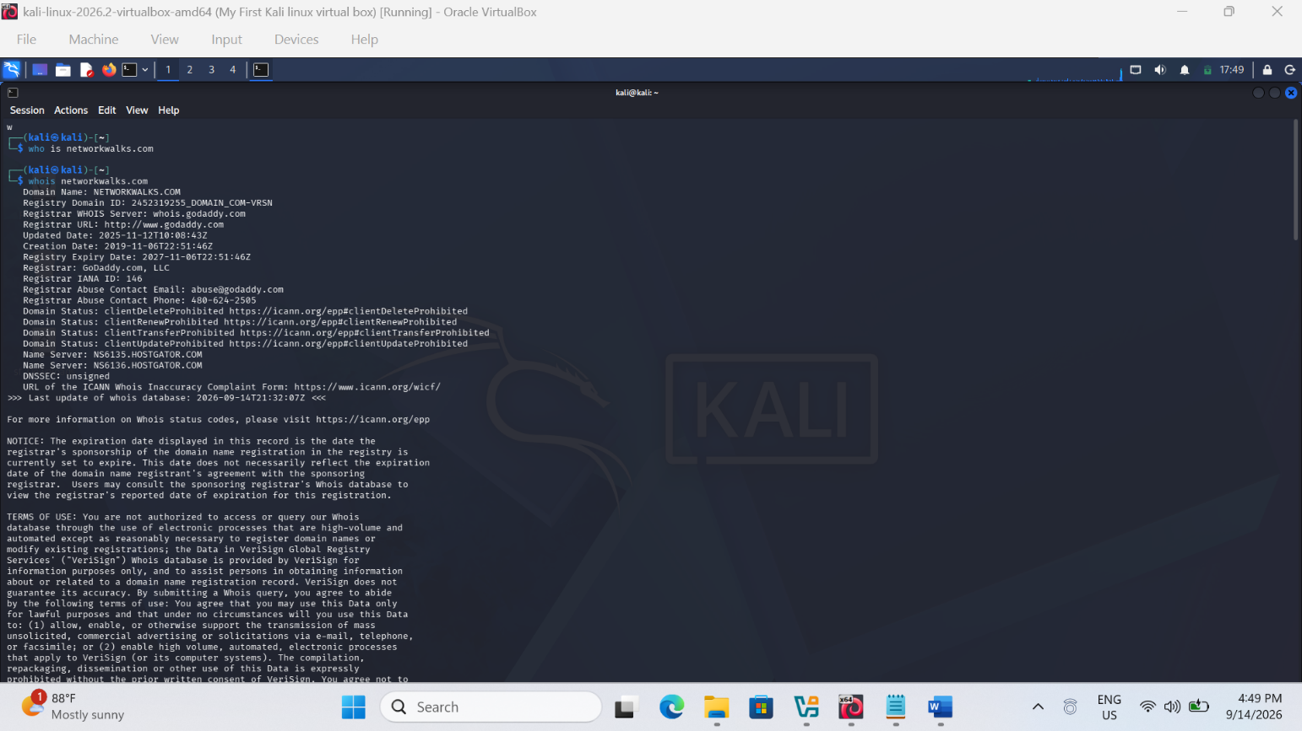
WhatWeb — Screenshot Evidence
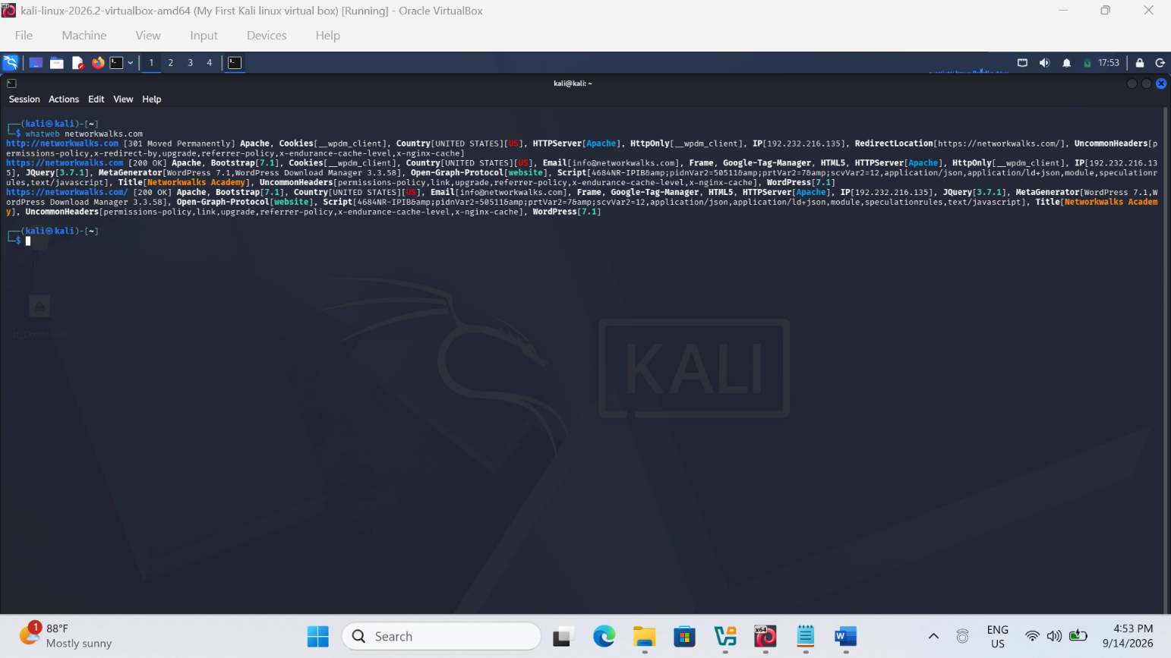
Nslookup — Screenshot Evidence
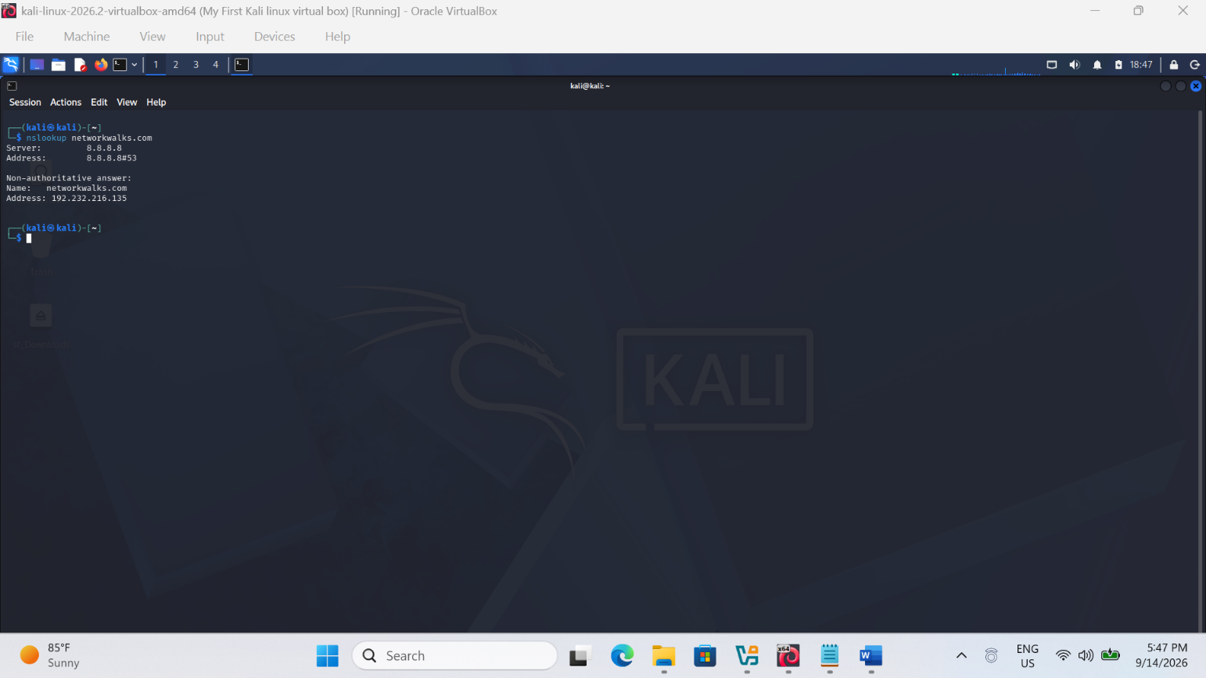Wafw00f — Screenshot Evidence
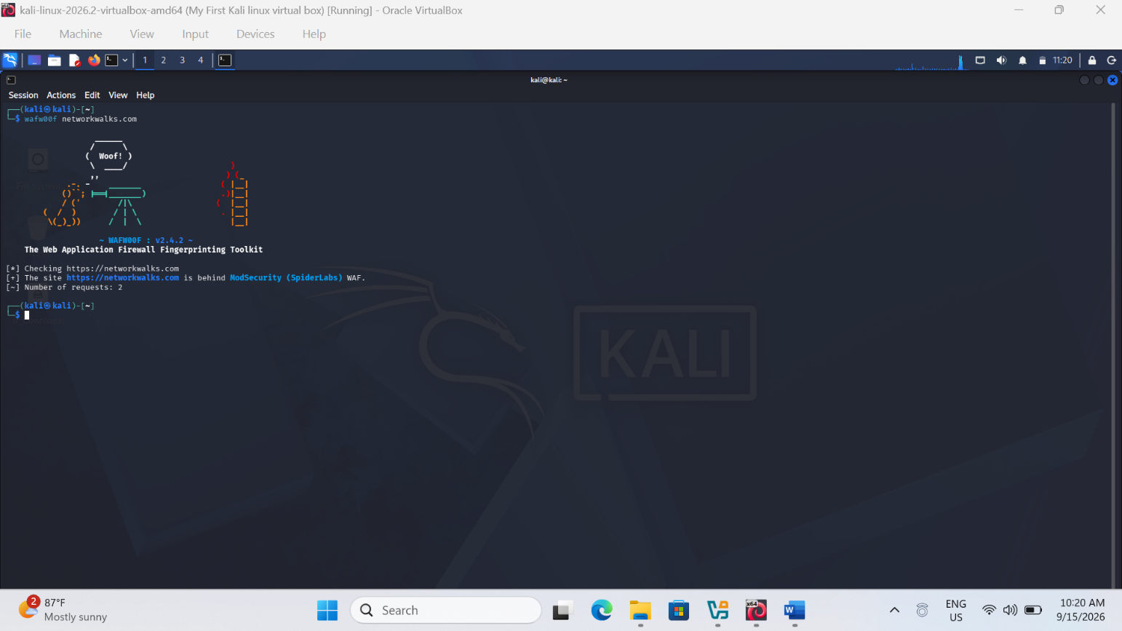
DNSRecon — Screenshot Evidence
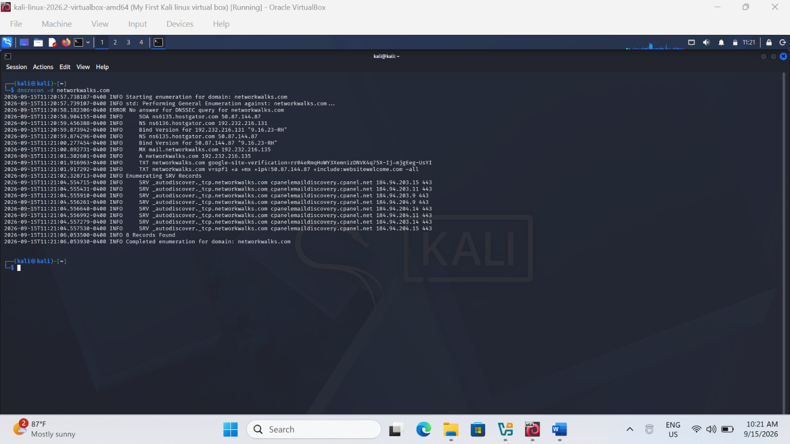

Zenmap — Screenshot Evidence
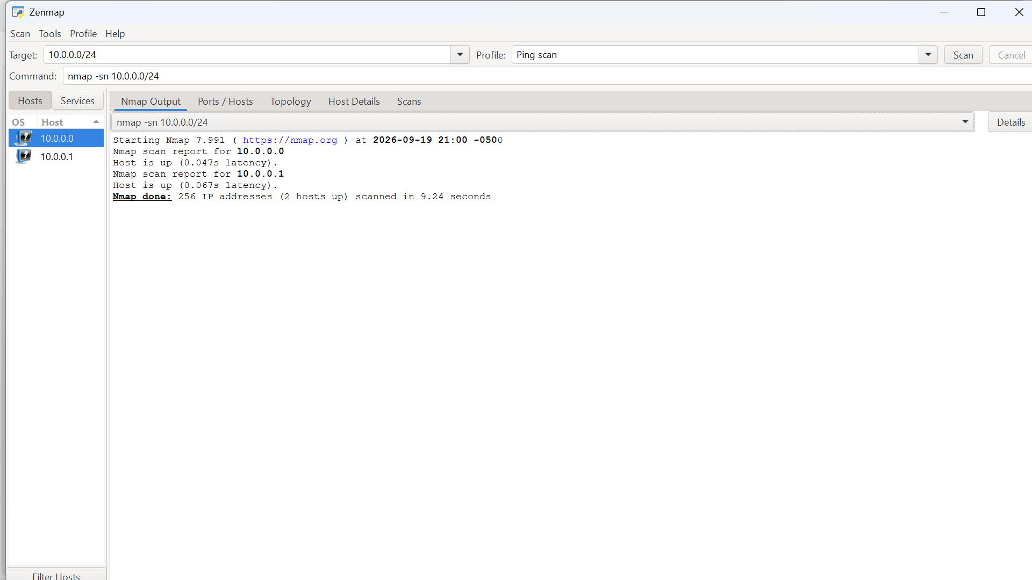
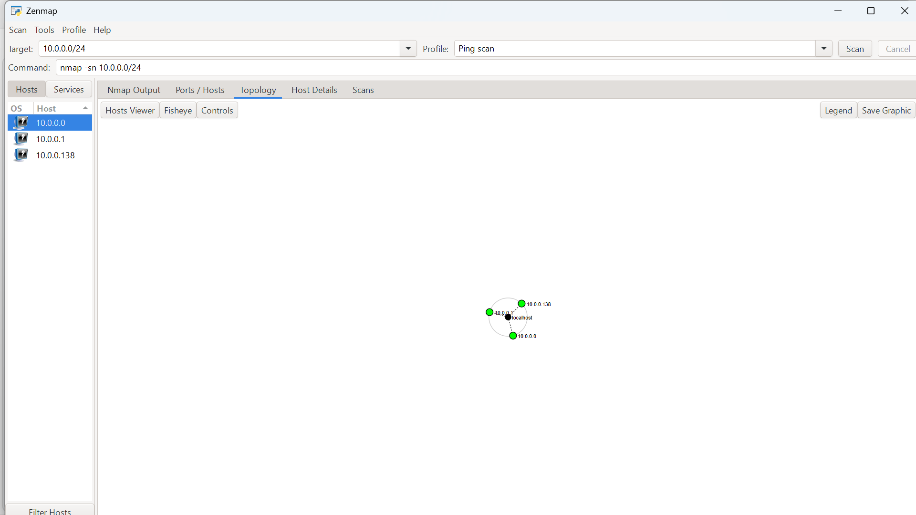

-End-

👤 Author
Jovanie Spencer
Cybersecurity Professional B083A
LinkedIn: https://www.linkedin.com/in/jovanie-spencer-3b73721aa/

📌 Project Information
Program Name: Cybersecurity program at Networkwalks | Week: 02 | Module: W2-PM1 and W2-PM5

